WEEK-1

CREATE DATABASE BOOKFLOW_DB AND USE DATABASE
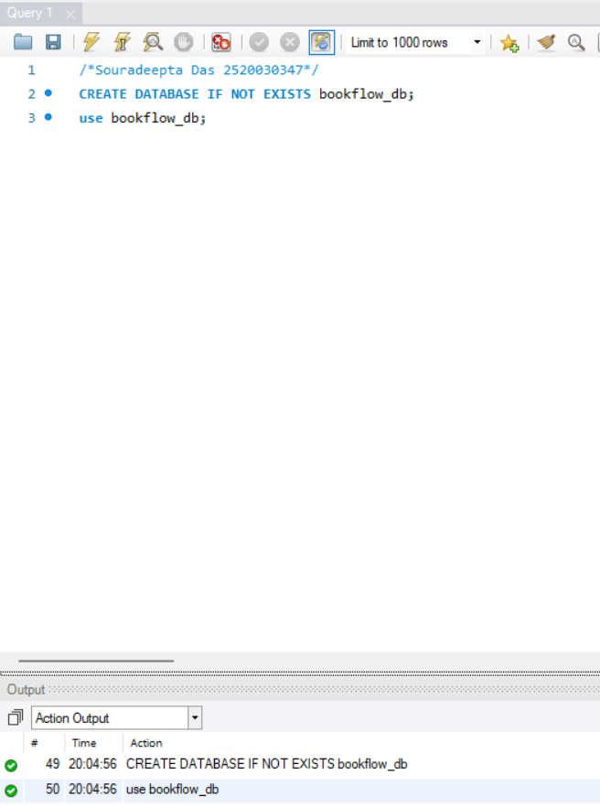

CREATE TABLE BOOKS
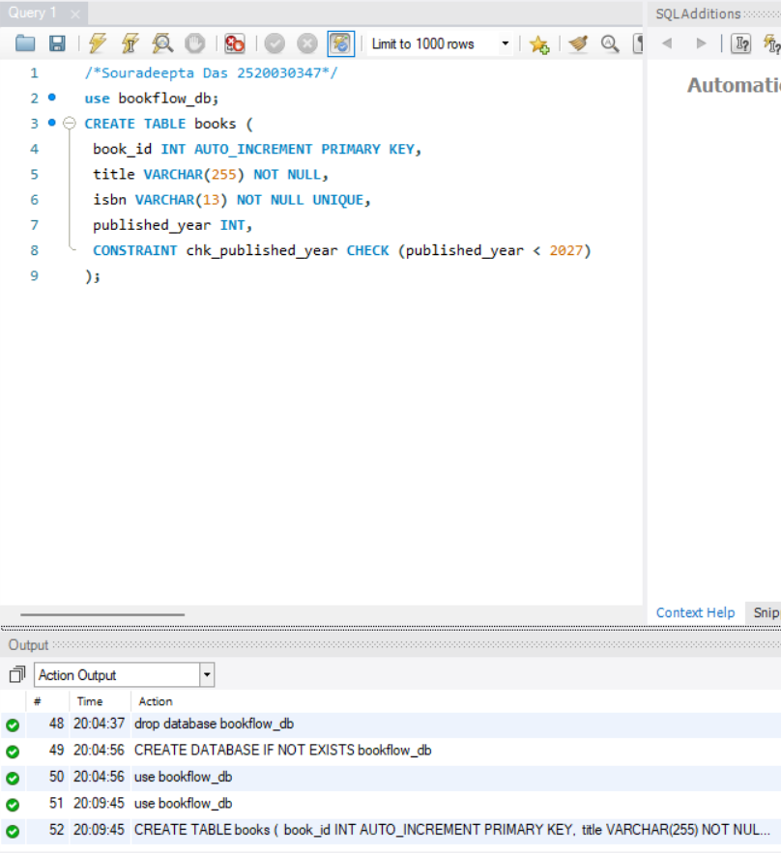
CREATE TABLE MEMBERS
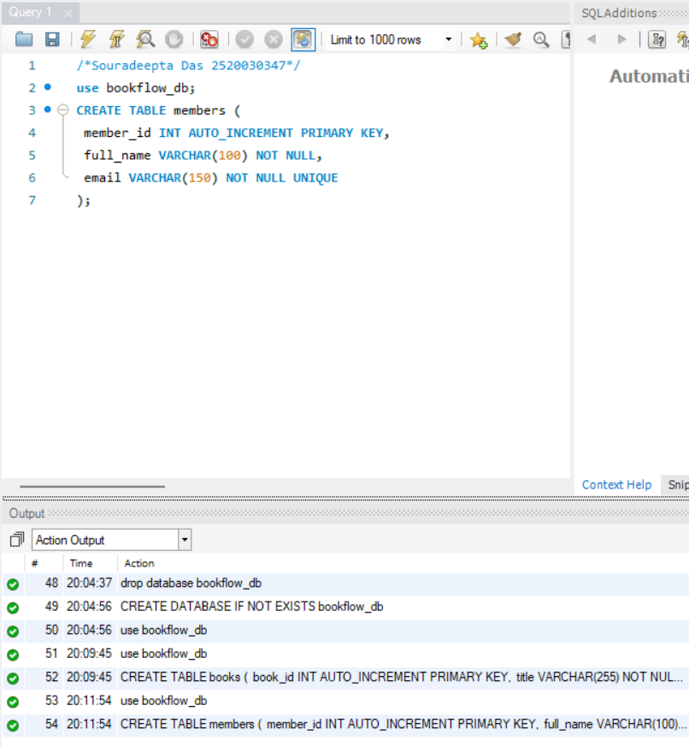

DESCRIBE BOOKS
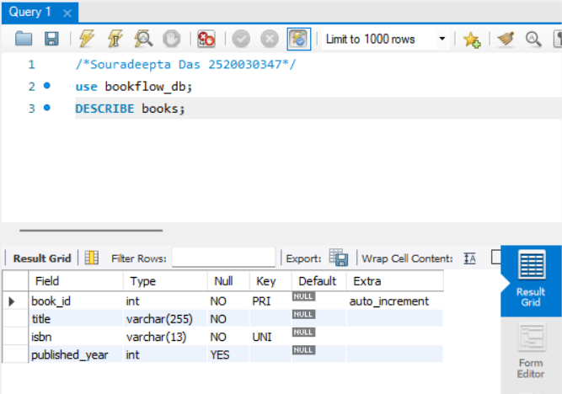

DESCRIBE MEMBERS
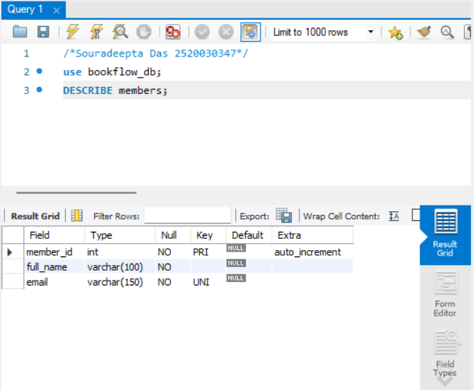
INSERT INTO BOOKS
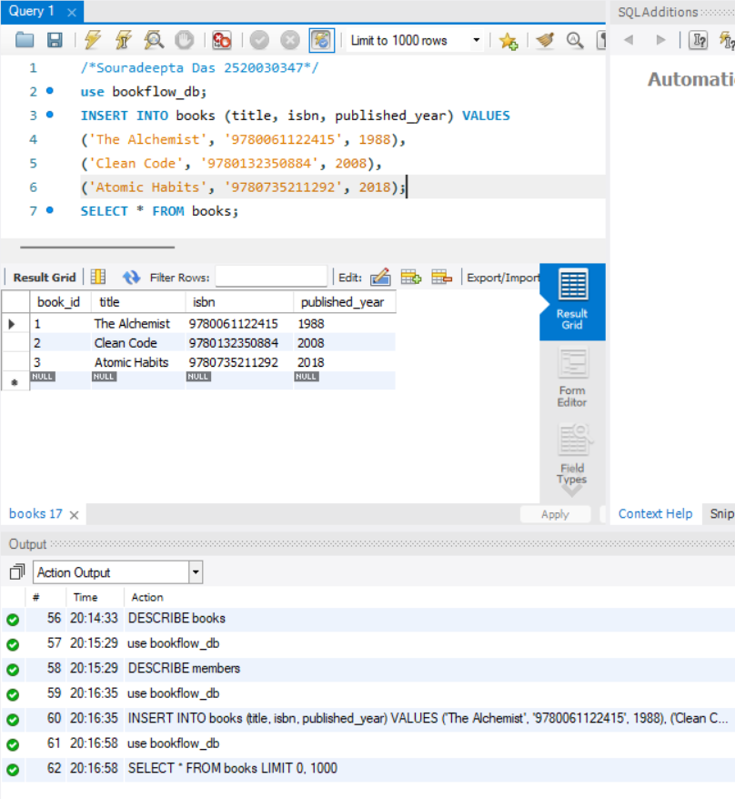

INSERT INTO MEMBERS
